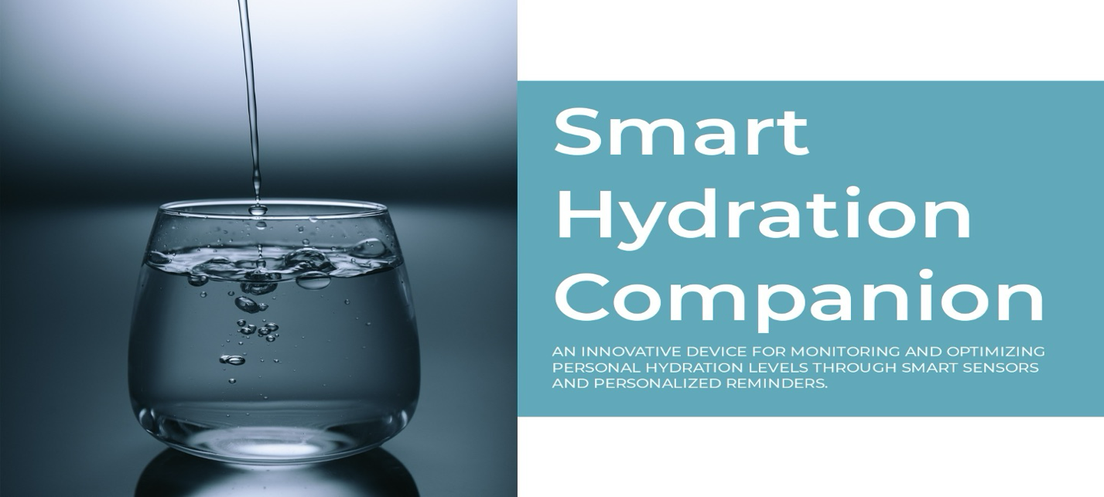Smart Hydration Companion Project

Table of Contents

Team Members: 3

Links: 3

Trello Page: 3

- GitHub Team Page: 3

Documentation and Research Links: 4

- Dehydration Statistics 2024 References: 4

Problem Outline and Research Background(update): 4

- The Importance of Hydration 5

- Physiological Importance of Hydration: 5

- Daily Hydration Requirements: 6

- Surprising Dehydration Statistics in 2024(new): 6

- Hydration Market Analysis: 7

Project Solution Summary(update): 7

- Bridging Technology with Wellness: 7

- Intelligent Hydration Reminders: 7

- Advanced Intake Tracking: 7

- Promoting Sustainable Hydration Practices 8

- A Comprehensive Hydration Management System 8

Comprehensive Project Requirements 9

Initial Design Concepts(update) 9

- Preliminary Design Sketch of Case(new): 12

Detailed Implementation Plan(update): 13

- Equipment List: 13

- 1. System Design and Equipment Integration: 13

- 2. Sensor and Amplifier Implementation 13

- 3. Interactive Display 13

- 4. User Interaction: 14

- 5. Auditory Alerts 14

- 6. Software Development and Prototyping: 14

- 7. Customisable Experience 15

- 8. Physical Design and Manufacturing: 15

- 9. Software Development and Backend Integration(new): 15

Rigorous Testing Strategy(update) 16

Security Considerations(update): 16

Vision for the Future: 16

- Miniaturisation and Integration: 17

Ethical Risk Assessment of the Smart Hydration Companion Project 18

Usage: 20

- Main Functions: 20

- Start-up Procedure: 20

- Menu Mode Options: 21

# **Team Members:**

* Emanuel S00256076@atu.ie
* Oleksandr S00251154@atu.ie
* Polina S00253277@atu.ie
* Davyd [S00255881@atu.ie](mailto:S00255881@atu.ie)

—————————————————————

# **Links:**

* Trello Page: <https://trello.com/invite/b/ZlEdFCIn/ATTIe7f918c676be86c1a19952f9255aa80068B913DF/iot-waterbottle-project>

## GitHub Team Page:

<https://github.com/OleksandrDemkiv/WaterBottleReminder>

—————————————————————

# **Documentation and Research Links:**

* <https://wiki.seeedstudio.com/Grove-LCD_RGB_Backlight/>
* <https://www.thingiverse.com/thing:6240150>
* <https://github.com/hibit-dev/buzzer>
* <https://www.traceminerals.com/blogs/post/staying-hydrated-in-the-summer-heat>
* <https://www.healthdirect.gov.au/drinking-water-and-your-health>
* <https://journals.physiology.org/doi/full/10.1152/ajpregu.00365.2002?origen=app>
* <https://randomnerdtutorials.com/arduino-load-cell-hx711/>
* [https://circuits4you.com](https://circuits4you.com/)
* <https://docs.arduino.cc/learn/starting-guide/getting-started-arduino/>

## **Dehydration Statistics 2024 References:**

* https://www.www.medicine.mcgill.ca
* https://www.www.dailymail.co.uk
* https://www.www.quenchwater.com
* https://www.www.meandermc.nl
* https://www.www.medicaldaily.com
* https://www.www.travelhealthpro.org.uk
* https://www.www.cdc.gov
* https://www.academic.oup.com
* https://www.pubmed.ncbi.nlm.nih.gov
* https://www.www.who.int
* https://www.www.ncbi.nlm.nih.gov
* https://www.medlineplus.gov
* https://www.www.water.org.uk

—————————————————————

# **Problem Outline and Research Background(update):**

Our world is more connected than ever, yet basic health practices like hydration are often overlooked. The human body's need for adequate water intake is a fundamental aspect of health, impacting everything from metabolism to cognitive function. However, modern lifestyles can make it challenging for individuals to remember and prioritise hydration.

Through comprehensive research, including scholarly articles and existing solution analyses, we've identified a significant gap in personal health management systems, particularly those that encourage sustainable practices. Our findings indicate a clear need for a more integrated, user-friendly approach to hydration.

* **The Importance of Hydration:**

The significance of hydration transcends basic thirst quenching; it is a cornerstone of human health, integral to virtually every bodily function. Water, the body's principal chemical component, plays a critical role in maintaining a healthy balance of body fluids, which are essential for digestion, absorption, circulation, creation of saliva, transportation of nutrients, and maintenance of body temperature. Here's a deeper look into the pivotal roles of proper hydration.

## 

## **Physiological Importance of Hydration:**

****Mood and Cognitive Function: Adequate hydration is linked to better mood and cognitive function. Dehydration can lead to fatigue, confusion, and anxiety, affecting mental performance and mood states. Studies have shown that even mild dehydration can impair memory, attention, and other cognitive functions.

Energy Levels: Water is essential for the body's metabolic processes, including the conversion of food into energy. Proper hydration ensures that these processes occur efficiently, contributing to overall energy levels. Dehydration can slow down metabolism, leading to feelings of lethargy and decreased physical performance.

Detoxification: Water helps flush toxins from the body through urination and perspiration. It supports kidney function, allowing these organs to filter and expel waste products efficiently. Inadequate hydration can hinder this detoxification process, potentially leading to the accumulation of toxins and an increased risk of kidney stones.

Digestive Health: Hydration is crucial for maintaining a healthy digestive system. It aids in dissolving fats and soluble fibre, allowing for smoother passage through the intestines and reducing the risk of constipation. Moreover, adequate water intake is vital for producing saliva, which starts the digestive process.

Skin Health: Hydrated skin is more elastic, plump, and less prone to dryness and wrinkling. While hydration alone won't prevent wrinkles, it's a key component in maintaining overall skin health and appearance.

Physical Performance: During physical activity, the body loses water through sweat. To maintain optimal performance, it's crucial to replace lost fluids. Dehydration can lead to decreased endurance, increased fatigue, and altered thermoregulation, all of which can impair athletic performance.

## **Daily Hydration Requirements:**

The commonly cited recommendation is for adults to consume about 2.7 to 3.7 litres of water per day, though this can vary based on factors like age, gender, weight, climate, and activity level. It's important to listen to your body's cues and consume fluids throughout the day, not just when you feel thirsty, as thirst is a late sign of dehydration.

Incorporating a variety of sources, including water, other beverages, and high-water-content foods (like fruits and vegetables), can help meet hydration needs. Moreover, monitoring the colour of your urine is a simple way to gauge your hydration status; pale yellow indicates proper hydration, while dark yellow can be a sign of dehydration.

In conclusion, maintaining adequate hydration is a simple yet effective way to support overall health and well-being. Given its extensive benefits, from enhancing mood and cognitive function to supporting physical performance and digestive health, it's clear that water is more than just a basic necessity—it's a vital component of a healthy lifestyle.

## **Surprising Dehydration Statistics in 2024(new):**

* 1.35 million deaths worldwide linked to dehydration annually.
* 2 billion people lack clean water access, heightening dehydration risks.
* Only 22% who know about dehydration drink enough water daily.
* About 75% of people may be chronically dehydrated.
* 5-10% of elderly mortality is due to dehydration.
* 37% of people often confuse thirst for hunger.
* 50% of children with gastroenteritis are dehydrated.
* 1 in 5 illnesses could be prevented with proper hydration.
* 500+ dehydration deaths in the UK each year.
* Diarrhoea, linked to dehydration, is the second leading cause of death in children under five.
* Dehydration increases heat illness risk at just 2% body weight loss during physical activities.
* Over 25% of marathon runners have had dehydration-related hyponatremia.
* Nearly 80% of working people don’t drink enough water.
* Since 1979, heat-related illnesses have caused over 9,000 deaths in the U.S., with dehydration a major factor.
* 1 in 10 sickness consultations for international travellers are due to dehydration.
* Dehydration contributes to 3% of elderly deaths in the U.S.
* Over 4 million people die yearly from dehydration-related diseases.
* 2 to 3 litters of water per hour can be lost during intense exercise, increasing dehydration risks.

## 

## **Hydration Market Analysis:**

There is a notable absence of solutions that combine hydration tracking with sustainable practices.

—————————————————————

# **Project Solution Summary(update):**

The Smart Hydration Companion project represents a significant leap forward in personal health technology, merging the conveniences of modern IoT devices with the essential human need for hydration. This innovative project is designed to address common obstacles to staying hydrated by providing a user-friendly, interactive solution that does more than just remind users to drink water. Here's an expanded view on how this project stands as a comprehensive solution to hydration management:

## **Bridging Technology with Wellness:**

Our daily lives are increasingly intertwined with technology, offering unprecedented opportunities to improve personal health practices. The Smart Hydration Companion leverages this integration, providing a seamless, intuitive means for individuals to monitor and enhance their hydration habits. This device is not just a technological novelty; it's a practical tool designed with the user's health and wellness at its core.

## **Intelligent Hydration Reminders:**

One of the central features of the Smart Hydration Companion is its ability to remind users to drink water at optimal times throughout the day. Unlike generic reminders, this device employs smart algorithms to personalise notifications based on the user's hydration needs, past intake. This proactive approach ensures that reminders are both relevant and timely, significantly increasing the likelihood of positive hydration habits.

## **Advanced Intake Tracking:**

Beyond mere reminders, the device excels in accurately tracking water intake. Utilising a sophisticated weight sensor, it measures the amount of water consumed with each drink, allowing users to see real-time updates on their hydration status. This feature provides a tangible sense of progress, encouraging users to meet or exceed their daily water intake goals. The project now focuses on a web-based solution to display hydration data. Utilizing Python, the backend is designed to receive data from the Arduino, process it, and prepare it for web display. The website will present data through interactive charts, enhancing user engagement and understanding.

Figure 1

## **Promoting Sustainable Hydration Practices**

Sustainability is a cornerstone of the Smart Hydration Companion's design. In an effort to combat the environmental impact of disposable water bottles, the device is engineered to work seamlessly with reusable bottles. This not only reduces plastic waste but also reinforces the importance of environmental consciousness in daily routines. By linking sustainable practices with personal health, the project advocates for a holistic approach to wellness that considers both the individual and the planet.

## **A Comprehensive Hydration Management System**

The Smart Hydration Companion transcends the capabilities of existing hydration solutions by offering a fully integrated system that reminds, tracks, and encourages sustainable water consumption. It addresses the common barriers to adequate hydration by making it easier for users to understand their personal hydration needs and to act on them effectively. The device's blend of smart technology, user-centric design, and environmental responsibility represents a novel approach to personal wellness, setting a new standard for how we incorporate hydration into our daily lives.

In summary, the Smart Hydration Companion project offers a multi-faceted solution to the challenge of staying adequately hydrated. By harnessing the power of IoT technology, it provides personalised, actionable insights into hydration habits, encourages the use of environmentally friendly practices, and empowers users to take control of their hydration health in a way that is both effective and sustainable. This project not only addresses the immediate needs of individual users but also contributes to a broader conversation about integrating health and sustainability into the fabric of everyday life.

—————————————————————

**Comprehensive Project Requirements***(Figure 2 & 3)****:***

* Customisable hydration reminders based on individual needs and intake.
* Accurate tracking of water intake using weight measurements.
* Calculation of personalised daily hydration goals.
* Real-time data display on the device and within an accompanying app.
* An energy-efficient design with a sustainability-focused sleep mode.

A user-friendly interface allowing for high degrees of personalisation.

Figure 2 Figure 3

————————————————————-

**Initial Design Concepts(update)**(Figure 4 & 5)**:**

* Device Sketches: Preliminary sketches showing the ergonomic and aesthetic design of the device.
* Code Architecture: A high-level overview of the proposed software architecture, highlighting modular design for easy updates.
* Hardware Setup: Diagrams detailing the electronic components and their integration.
* APIs and Data Processing: Description of planned APIs for data syncing between the device and app, ensuring a seamless user experience.

Figure 4

*Figure 5*

Figure 6


## **Preliminary Design Sketch of Case(new):**

*Figure 6*

* + 1. - The accompanying (Figure 6) sketch illustrates the preliminary design of the case intended to house the electronic components of our Smart Hydration Companion. These early designs play a crucial role in visualizing the practical application of our theoretical research and guiding the subsequent stages of physical prototyping.
  1. - Displayed bellow (Figure 7) is the finalized design of the case that encloses the project's electronic systems. The design was refined through multiple iterations to optimize space utilization and functionality while ensuring durability and accessibility for maintenance. This case is crucial for protecting the delicate electronic components and integrating them seamlessly into the overall design of the Smart Hydration Companion.

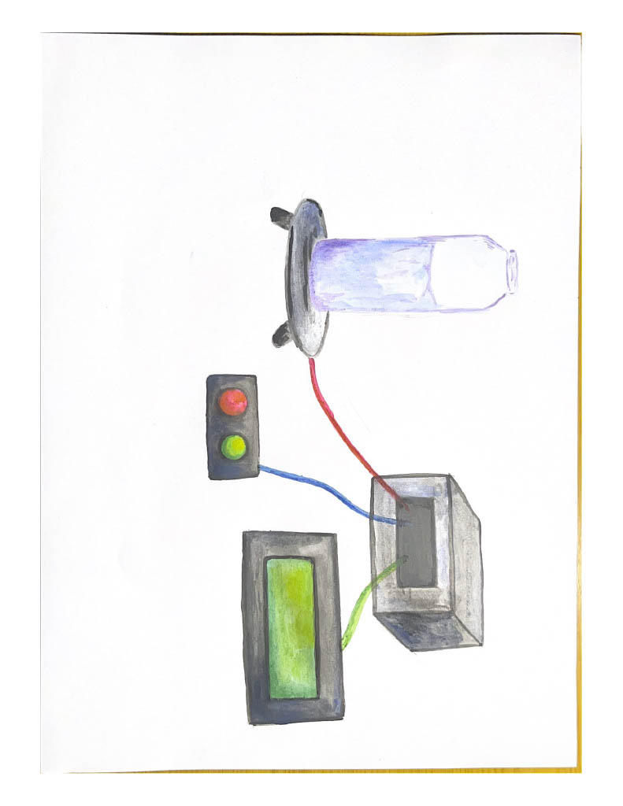

*Figure 7*

# **Detailed Implementation Plan(update):**

## **Equipment List:**

* + Arduino board
  + Grove - Dual Button
  + Weight sensor and amplifier
  + LCD RGB Backlight for display
  + Arduino-compatible speaker for alerts

## **A screen shot of a computer code Description automatically generated- 1. System Design and Equipment Integration:**

- Our system centres around an Arduino Yun board, selected for its versatility, ease of programming, and widespread community support. This microcontroller serves as the brains of our operation, handling input from the weight sensor and buttons, driving the display, and activating the speaker for alerts.

**- 2. Sensor and Amplifier Implementation***(Figure 8)****:***

Figure 8

- A high-precision weight sensor, paired with its amplifier, forms the cornerstone of our hydration tracking. The sensor's readings are amplified for clarity and sent to the Arduino, allowing for real-time monitoring of water intake.

**- 3. Interactive Display***(Figure 9)*

- An LCD with RGB backlight provides real-time feedback to users. This display shows the current weight of the water bottle, the calculated intake, and reminder notifications, ensuring users are always informed about their hydration status.

Figure 9

## **- 4. User Interaction:**

- Two Grove - Dual Buttons are employed for user interaction, allowing individuals to acknowledge hydration reminders and customise settings such as intake goals and reminder frequencies.

**- 5. Auditory Alerts***(Figure 10)***:**

- An Arduino-compatible speaker, integrated into the system, delivers audible alerts to remind users to hydrate. Thanks to user tmekinyan's contribution on projecthub.arduino.cc, we've implemented a customisable soundtrack for the reminder ringtone, offering a personalised experience for our users.

## **- 6. Software Development and Prototyping:**

Figure 10

- Initial coding and system testing began on the Wokwi simulator, ensuring our code functions correctly before physical prototyping. We've utilised numerous resources, from Arduino forums to YouTube tutorials, to refine our code and functionality.

**- 7. Customisable Experience***(Figure 11)***:**

- Emphasising personalisation, we've integrated the option for users to customise their reminder ringtones, making the experience of receiving a hydration alert more enjoyable and less intrusive

Figure 11

## **- 8. Physical Design and Manufacturing:**

- The physical unit that houses our electronics has been meticulously designed with user experience in mind. We have crafted a 3D printed base that securely holds the device and allows for easy placement of a water bottle on the weight sensor. The attached screenshots from the Wokwi simulator and the detailed drawings of the base showcase our commitment to a user-friendly design.

## **- 9. Software Development and Backend Integration(new):**

- The backend of our web-based hydration tracking system is powered by Python, which receives data from the Arduino setup. This architecture was selected to replace the initial mobile app concept, effectively addressing Arduino’s limitations by leveraging Python’s robust data handling capabilities. This switch not only simplifies the system's architecture but also enhances its scalability and security, providing a solid foundation for further development and the integration of additional functionalities.

-

—————————————————————

**Rigorous Testing Strategy(update)***(Figure 12)***:**

* + We adopted a phased testing approach, starting with individual component validation using simulation tools like Wokwi, progressing to integrated system testing, and culminating in real-world user trials. Our testing strategies for the website include ensuring the accuracy of the data displayed, conducting load tests to assess server response times, and usability testing to validate the effectiveness of the user interface in presenting hydration data. This comprehensive testing framework ensures the platform's reliability and user-friendliness.

Figure 12

—————————————————————

# **Security Considerations(update):**

* + Security analysis focused on ensuring data integrity and privacy, with encryption standards applied to data storage and transmission. To enhance user data privacy further, future security measures will include encrypting data transmissions and local file encryption. Currently, the hydration data is stored locally, ensuring it is accessible only through the website, which provides an added layer of security.

—————————————————————

# 

# **Vision for the Future:**

* + Expanding on the vision for the future of the Smart Hydration Companion project, we foresee a transformative evolution in how individuals monitor and manage their hydration, making the process more intuitive, personalised, and environmentally conscious. To further enhance the capabilities of our system, the implementation plan has now been expanded to include the setup of a dedicated web server. This server will host our web application, enabling dynamic interaction with users through an accessible platform.

## **Miniaturisation and Integration:**

* + We plan to develop a more compact design for the Smart Hydration Companion, aiming for integration directly into a smart water bottle. This approach not only enhances portability but also ensures that hydration tracking becomes an integral part of the water consumption process. By embedding the device within the bottle itself, users will benefit from a seamless experience that encourages regular use and accurate tracking.
  + **Temperature Sensing for Personalised Reminders:**
  + Recognising the impact of environmental conditions on hydration needs, we intend to incorporate temperature sensors into the smart water bottles. These sensors will assess the external temperature and adjust hydration reminders accordingly. On warmer days, the device will increase the frequency of reminders to encourage more frequent water intake, while cooler conditions will result in adjusted reminder intervals to reflect decreased hydration requirements. This adaptive reminder system ensures that hydration advice is always tailored to the user's immediate environment, enhancing the relevance and effectiveness of hydration prompts.
  + **Enhanced App Functionality for Comprehensive Health Management:**
  + The accompanying mobile application will undergo significant enhancements to offer a more holistic view of the user's health and hydration habits. The app will integrate data from the smart bottle's sensors, including water intake and temperature readings, with information from other health and fitness trackers. This integration will enable personalised hydration recommendations that consider the user's activity level, dietary intake, and environmental conditions. Additionally, the app will feature a user-friendly interface with customisable goals, progress tracking, and motivational rewards to encourage consistent hydration and overall wellness.
  + **Conclusion:**
  + The planned improvements for the Smart Hydration Companion project represent a significant step forward in personalised health technology. By focusing on miniaturisation, sensor integration, and enhanced app functionality, we aim to provide users with a comprehensive and intuitive solution to manage their hydration effectively. These developments not only promise to improve individual health and wellness but also contribute to environmental sustainability by promoting the use of smart, reusable water bottles. Through these innovations, we envision a future were staying hydrated is effortless, personalised, and integrated into daily life.

—————————————————————

# **Ethical Risk Assessment of the Smart Hydration Companion Project**

* + As part of our commitment to responsible development and the implementation of the Smart Hydration Companion Project, we have conducted a comprehensive Ethical Risk Assessment. This evaluation aims to proactively identify and mitigate potential ethical challenges associated with our technology. Using the Ethical OS Toolkit, we have analyzed several risk zones pertinent to our project's features and functionalities.
  + The table below (Figure 13) details each identified risk zone, descriptions of potential risks, their likelihood and impact, and the calculated risk scores. We also outline specific remediation actions to address these concerns, ensuring our project aligns with ethical best practices and promotes user trust and safety. This assessment underscores our ongoing effort to not only innovate but also maintain the highest ethical standards in our operations.

*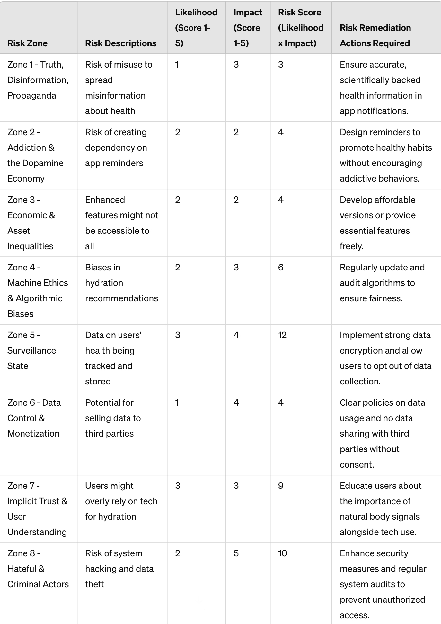Figure 13*

# **Usage:**

## **Main Functions:**

*Water Intake Recording*

* **Last Intake Display:** Each water intake is immediately displayed in millilitres for the user's reference.
* **Data Storage:** The system records and stores the volume of water consumed during each drinking session.

*Timer with Alarm*

* **Hydration Reminder:** An alarm sounds at pre-set intervals to prompt the user to drink water.
* **Customisation:** The reminder period and alarm tone are adjustable through the menu mode.

*Sleep Mode*

* **Energy Conservation:** The display screen turns off to conserve energy, while the reminder timer remains active.
* **Activation:** Sleep mode is automatically overridden by the alarm, any button press, or when the bottle is lifted.

*Menu Mode*

**Program Customisation:** Users can personalise program settings, including background colour and alarm tone.

## **Start-up Procedure:**

Upon start-up, the system prompts the user to clear the platform and then place the water bottle on it to initialise the tracking process.

*Main Screen Interaction*

* **To record water intake:** Lift the bottle, drink, then replace the bottle and press the red button.
* **To activate sleep mode:** Press the blue button.
* **To access the menu:** Simultaneously press the red and blue buttons.

*Sleep Mode Activation and Deactivation*

* **Enter sleep mode**: by pressing the blue button.
* **Exit:** by pressing any button, lifting the bottle, or when the reminder alarm activates.

*Menu Mode Access and Navigation*

* **Enter:** by pressing both buttons together.
* **Navigate:** using the blue button to cycle through options or the red button to select an option.
* **To exit**: press both buttons simultaneously.

## **-** **Menu Mode Options:**

*Timer Setup*

* Increment timer by 30 minutes with the blue button, decrease with the red button.
* Save and exit by pressing both buttons together. If the timer is set to zero, the previous interval will be retained.

*Do Not Disturb*

* Toggle on or off with the blue button.
* Confirm and exit with the red button.

*Change Song*

* Navigate categories with the blue button and select with the red button.
* Within the song menu, cycle through songs with the blue button and select with the red button to exit.

*Change Colour*

* Cycle through colour options with the blue button and select with the red button.

—————————————————————

**RolesEmmi**

* Our research and voice of the customer. Emmi dove into the data and user insights, laying down the foundation of what our Smart Hydration Companion needed to be.

**Oleksandr**

* The coding powerhouse of the team. Alex brought the Smart Hydration Companion to life, juggling backend and frontend coding to create a seamless experience. His hands made our ideas work in the real world.

**Polina**

* The creative force behind the Companion's look and feel. Pauline’s designs didn’t just make things look pretty; they made them feel right. She also pitched in on the research.

**Davyd**

* Our jack-of-all-trades. David was everywhere—researching, coding, fine-tuning the frontend. He made sure our Companion not only worked well but also made sense to our users and stood up to the rigours of daily life.

Together, we each poured a bit of our expertise and a lot of our passion into this project, blending tech and touch to keep our users healthily hydrated